Lab 2: Looking at the Hardware

Windows edition, System, Computer name
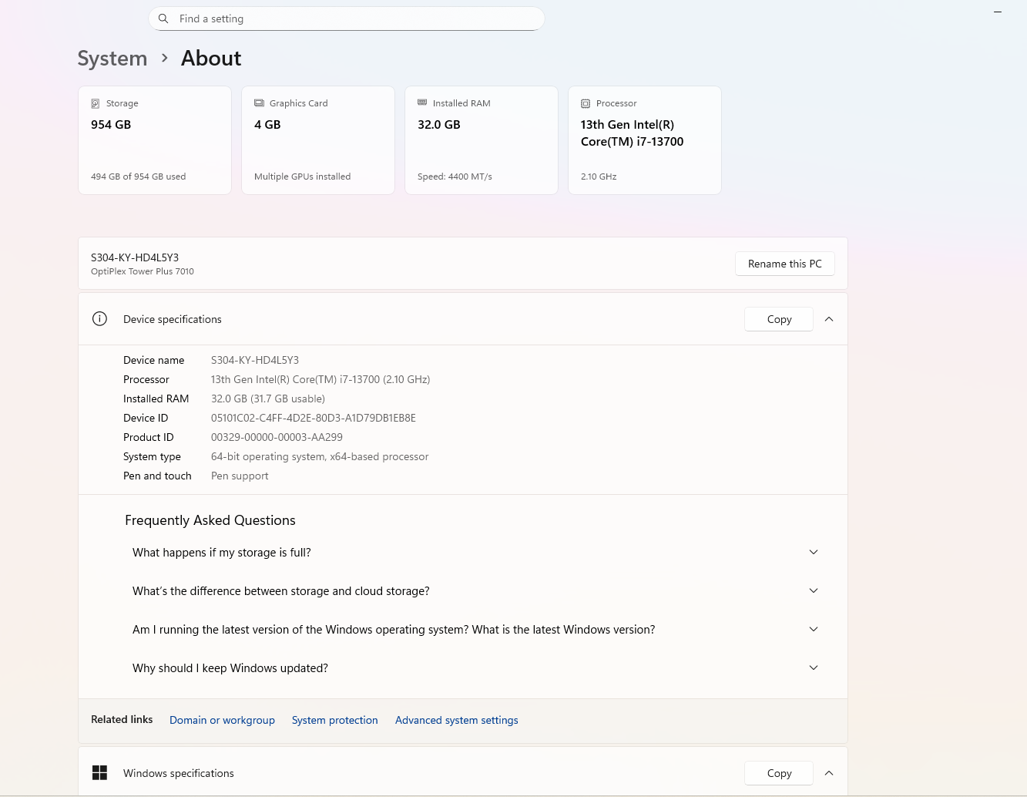

Windows activation
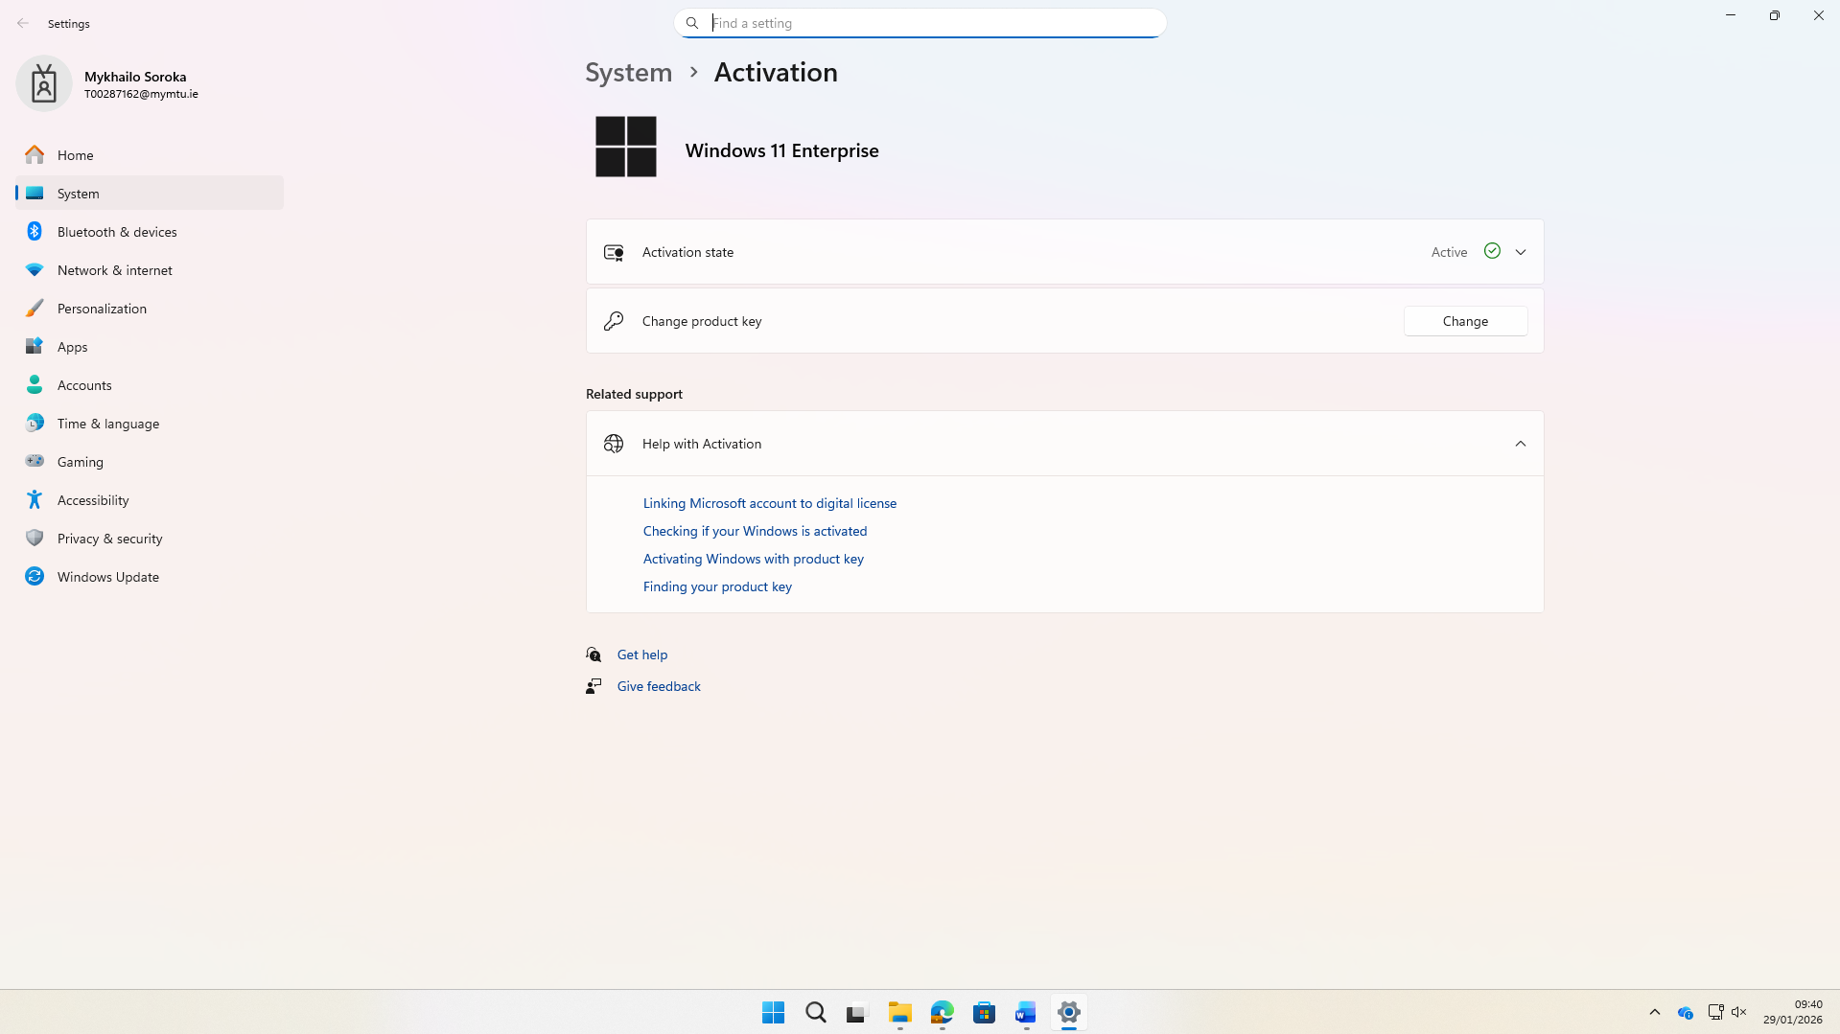

Device Manager
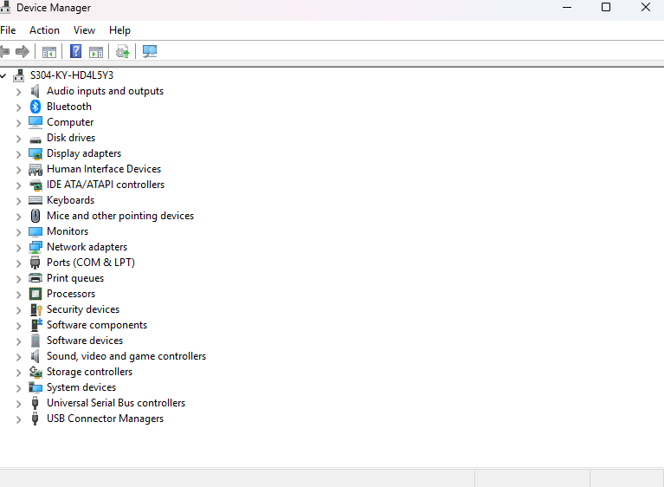

Remote settings
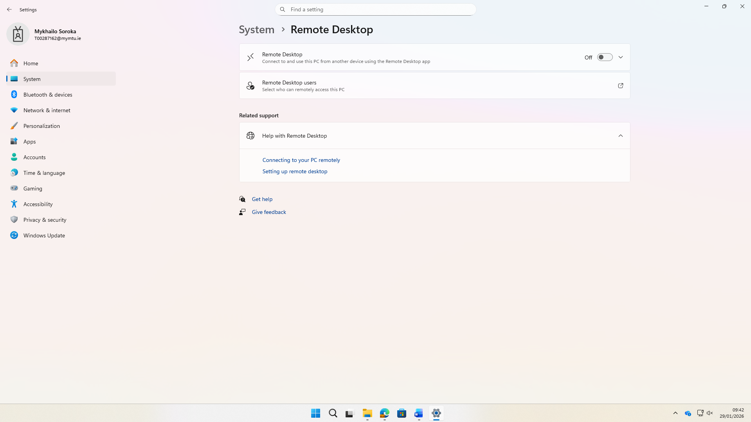

System protection
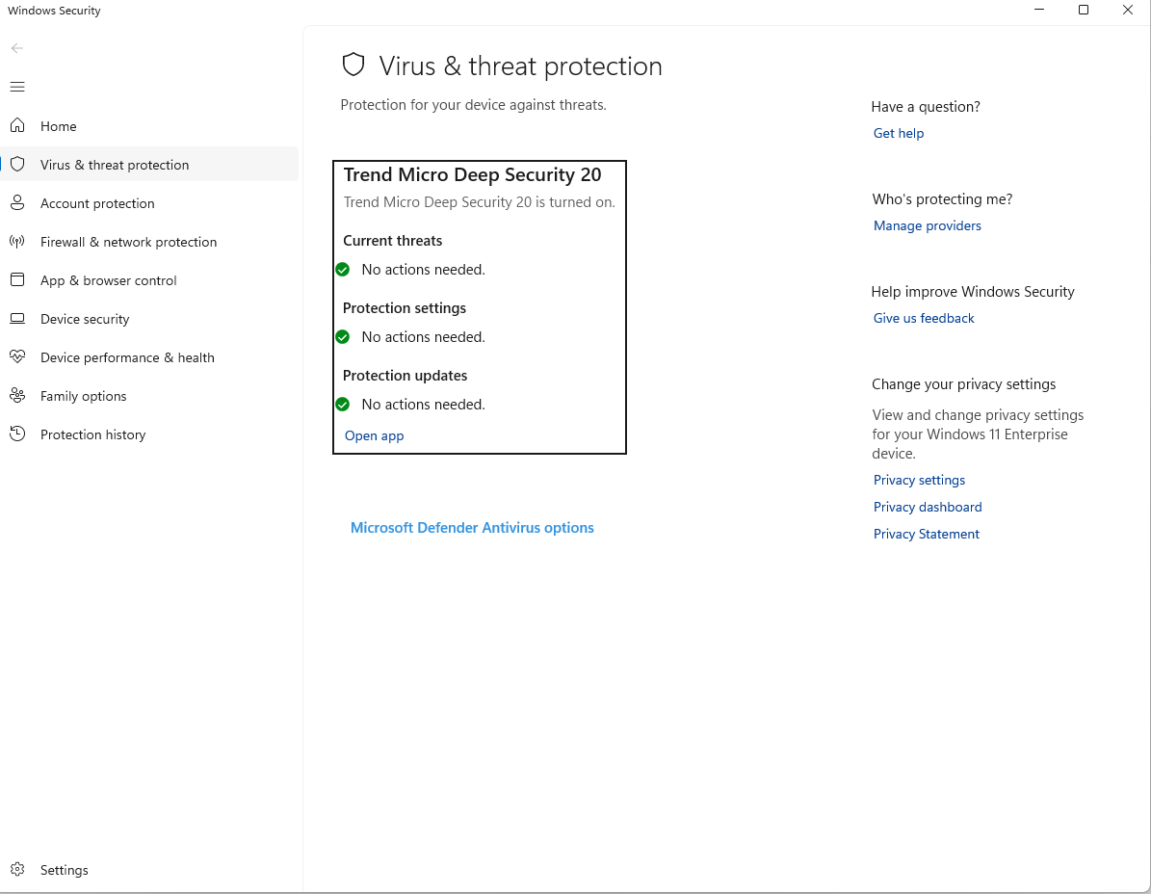

Advanced system settings
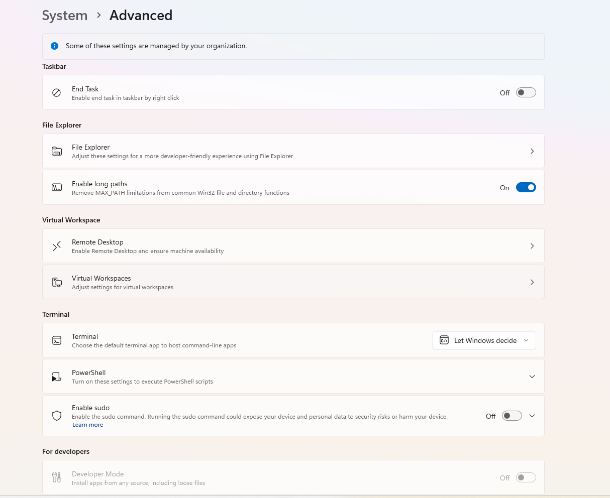

Specify the following:
• Version of Windows 11 installed: Windows 11 Enterprise 24H2
• The processor: 13th Gen Intel(R) Core(TM) i7-13700
• The Speed of the processor: 2.10 GHz
• The amount of RAM: 32GB
• The Operating System Edition: 26100.7623
• Locate the webpage with your processor specifications.
Intel® Core™ i7-13700 Processor
• What is the function of BitLocker? Is BitLocker available on your PC? Provide a link
to documentation related to BitLocker.

BitLocker is a full-disk encryption tool that is part of Windows, allowing the entire volume to be encrypted to protect the information from being accessed by unauthorized users, especially in cases of loss or theft of the device. This tool utilizes strong encryption methods, such as AES, and can also use a TPM to protect the encryption keys.
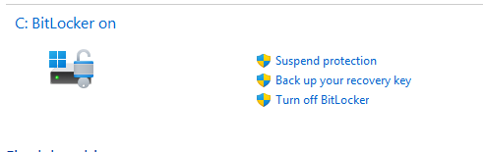
https://learn.microsoft.com/en-us/windows/security/operating-system-security/data-protection/bitlocker/faq?utm_source=chatgpt.com

• According to the provided FAQs, what happens if your storage is full?
BitLocker doesn’t stop working if storage is full — encryption continues in the background as disk space becomes available.

Joining Domain/Workgroup
What is the Computer Name on your machine?
S304-KY-HD4L5Y3.tech.ittralee.ie
What Domain/Workgroup is it a member of? Provide a screenshot.
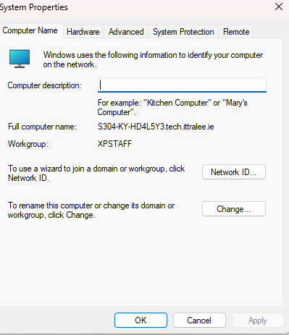

Hard Disks

What type of Disk Format is used on the C: drive NTFS
What is the Capacity of the C drive? 951 GB
Provide the screenshot with detailed storage usage on your drive. 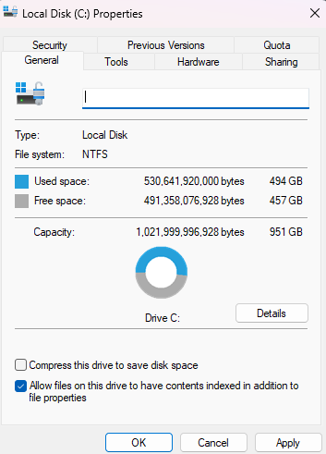
Provide a screenshot with the Quota settings.
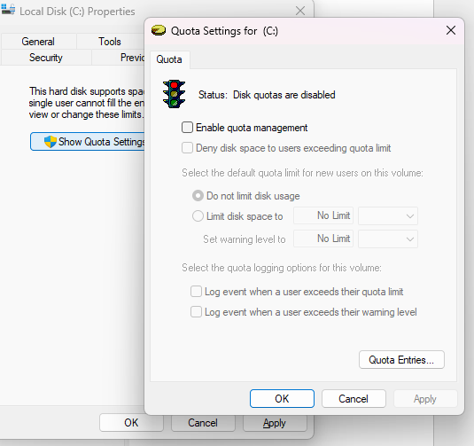

Optimize and Defragment Hard Disk Drive
Exercise: Can you verify the sector size using the System Information
Utility on Windows? 512

Using Disk Defragmenter
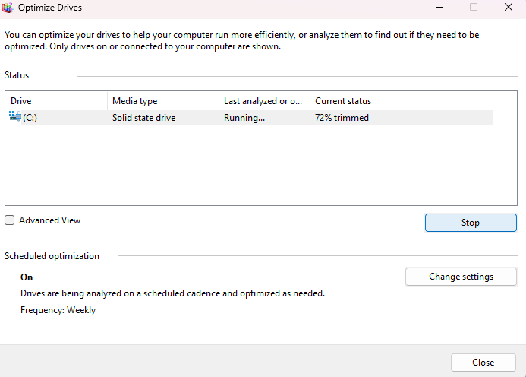

Disk Management
How many partitions are on your machine? 2
For each partition specify the following:
Volume: ___________________
Layout: ___________________
Type: ___________________
File System: ___________________
Capacity: ___________________
Free Space: ___________________
Note: Copy the above for each volume
Exercise:
Discuss the disk configuration in the following screenshots. List the steps to make the disk
available where required.

